Hotel Management Website

Software Development Plan (Small Project)

Version <1.1.1>

Revision History

|  |  |  |  |
| --- | --- | --- | --- |
| **Date** | **Version** | **Description** | **Author** |
| 10/11/2022 | 1.0 | Create a project plan | Nguyen Le Son |
| 12/11/2022 | 1.1 | Change Organizational Structure, and Edit Project Plan | Nguyen Le Son |
| 26/11/2022 | 1.1.1 | Change Project Plan  Add Gantt Chart  Fix Grammar Errors | Nguyen Le Son |
|  |  |  |  |

Table of Contents

1. Introduction 4

1.1 Purpose 4

1.2 Scope 4

1.3 Overview 4

2. Project Overview 4

2.1 Project Purpose, Scope, and Objectives 4

2.2 Assumptions and Constraints 4

2.3 Project Deliverables 4

3. Project Organization 5

3.1 Organizational Structure 5

3.2 Roles and Responsibilities 5

4. Management Process 5

4.1 Project Estimates 5

4.2 Project Plan 5

4.3 Project Monitoring and Control 7

4.3.1 Requirements Management 7

4.3.2 Reporting and Measurement 7

4.3.3 Risk Management 7

4.3.4 Configuration Management 8

Software Development Plan (Small Project)

# Introduction

## Purpose

The purpose of the *Software Development Plan* is to gather all information necessary to control the project. It describes the approach to the development of the software and is the top-level plan generated and used by managers to direct the development effort.

The following people use the *Software Development Plan*:

* The **project manager** uses it to plan the project schedule and resource needs, and to track progress against the schedule.
* **Project team members** use it to understand what they need to do, when they need to do it, and what other activities they are dependent upon.

## Scope

This *Software Development Plan* describes the overall plan to be used by the Hotel Management project, including deployment of the product. The details of the individual iterations will be described in the Iteration Plans.  
The plans as outlined in this document are based upon the product requirements as defined in the *Vision Document*.

## Overview

This *Software Development Plan* contains the following information:

Project Overview — provides a description of the project's purpose, scope, and objectives.  It also defines the deliverables that the project is expected to deliver.

Project Organization — describes the organizational structure of the project team.

# Project Overview

## Project Purpose, Scope, and Objectives

With the goal of supporting hotels in managing their employees and customers, this project was implemented with the aim of creating a management program specifically for hotels. The above program helps to support the management of staff in the hotel and creates tools to support convenient services for customers.

## Assumptions and Constraints

Time to make the project: 8 weeks(include 2 weeks of learning flutter, API,…)

Equipment: A device that can code the program and have a lot of storage space in the device to do.

Staff: All the members in the group.

## Project Deliverables

Deliverables for each project phase are identified in the Development Case. Deliverables are delivered toward at the end of the iteration (in 4.2)

# Project Organization

## Organizational Structure

## Roles and Responsibilities

|  |  |  |
| --- | --- | --- |
| **Person** | **Role** | **Responsibility** |
| Nguyen Le Son | Team leader, Web developer | Leader of team; Manage the project: Make a schedule for the project, check the process,…; Code, maintain and update the website |
| Le Tran Trung Hieu | Assistant, Project Manager | Support other roles if they need help, manage projects on Github |
| Vu Huy Hoang | Web developer | Code, maintain and update the website |
| Tran Le Hoang Bao | Back-end developer | Code the back-end data structure for the website |
| Lam Vi Nguyen | Back-end developer | Code the back-end data structure for the website |

# Management Process

## Project Estimates

Time cost for the project: 8 weeks.(Include 2 weeks to learning new code language and 6 weeks to work)

Budget cost: Free ( Using free source to do)

## Project Plan

|  |  |  |  |  |  |
| --- | --- | --- | --- | --- | --- |
| **No.** | **Task** | **Request** | **Member take part in** | **Start** | **End** |
| 1 | Learning Flutter | Find and learn Flutter. | All Members in group | 15/10/2022 | 28/11/2022 |
| 2 | Create the website | Code the website by Flutter. In this website, it will have all the functions that teams are listed in the meeting(PA0). | Nguyen Le Son,  Vu Huy Hoang | 07/11/2022 | 28/11/2022 |
| 3 | Create the back-end for the website | Find the API that will need and code the back-end of the website. | Lam Vi Nguyen,  Tran Le Hoang Bao | 07/11/2022 | 28/11/2022 |
| 4 | Support Back-end team | Ask Front-end Team about the functions they need to add and what they will do with the data in API | Le Tran Trung Hieu | 07/11/2022 | 28/11/2022 |
| 5 | Research add API to Flutter | Find solution to add API to Flutter | Lam Vi Nguyen,  Tran Le Hoang Bao,  Le Tran Trung Hieu | After the deadline of Task 2,3,4 | 05/12/2022 |
| 6 | Combine the website and back-end | Code the system that combines the website and back-end. | Lam Vi Nguyen,  Tran Le Hoang Bao,  Vu Huy Hoang,  Le Tran Trung Hieu | After the deadline of Task 5 | 15/12/2022 |
| 7 | Test and fix the bug |  | All the members of the group | After the deadline of Task 6 | 25/12/2022 |
| 8 | Manage the project in Github | Check pull requests from all the members and manage the project in Github. | Le Tran Trung Hieu | 15/10/2022 | Release the final product |
| 9 | Make a schedule of weekly meeting and write report | Make a schedule of weekly meetings and write reports. | Nguyen Le Son |  |  |
| 10 | Do the PA_ |  | Members that Team leader chose | In progress | In progress |

* **Gantt chart of Project Plan:** the PA work will be added when the Team leader is assigned.

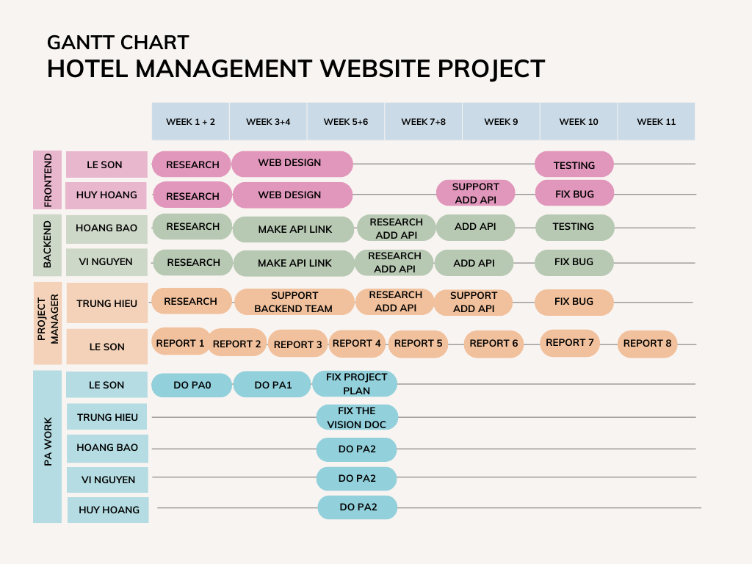

## Project Monitoring and Control

### Requirements Management

The requirements for this system are captured in the Vision document. Requested changes to requirements are captured in Change Requests, and are approved as part of the Configuration Management process.

### Reporting and Measurement

None

### Risk Management

Risks will be identified in the Inception Phase using the steps identified in the RUP for Small Projects activity “Identify and Assess Risks”. Project risk is evaluated at least once per iteration and documented in this table. The risks of the greatest magnitude are listed first in the table.

|  |  |  |
| --- | --- | --- |
| **Risk Ranking (High, Medium, Low)** | **Risk Description and Impact** | **Mitigation Strategy and/or Contingency Plan** |
| High | Web developer don’t know enough about flutter | Have someone with better knowledge on flutter help the other person |
| Medium | Can’t work on their task due to other subject deadline | Project manager has to reschedule and scale down expectation |
| Medium | The one that owns the github project don’t response | Transfer the managing right to the other person |
| Low | Faulty pull request merge | Revert to earlier working version |

### Configuration Management

Appropriate tools will be selected which provide a database of Change Requests and a controlled versioned repository of project artifacts.

All source code, test scripts, and data files are included in baselines. Documentation related to the source code is also included in the baseline, such as design documentation. All customer deliverable artifacts are included in the final baseline of the iteration, including executables.